Institute of Computer Technology

B. Tech Computer Science and Engineering

Subject: DS (2CSE302)

**PRACTICAL-8**

**AIM: - Implement the scenario based on string.**

**1. Soham is class teacher of standard 3 and he wants to add students first name as per their current seating. After that he wants to set it in alphabetical order. Kindly refer the given scenario and provide appropriate solution in C.**

**Enter the number of students:6**

**Enter the name of student-1:Yagnik**

**Enter the name of student-2:Kashyap**

**Enter the name of student-3:Kasturi**

**Enter the name of student-4:Flora**

**Enter the name of student-5:Abhi**

**Enter the name of student-6:Nisha**

**Student List as per alphabetical order:**

**Abhi**

**Flora**

**Kashyap**

**Kasturi**

**Nisha**

**Yagnik**

***SOLUTION***

#include<stdio.h>

#include<string.h>

int main()

{

char yash[10][20] , temp[20];

int n , i , j;

printf("\nEnter the number of students: ");

scanf("%d",&n);

for(i=0 ; i<n ; ++i)

{

printf("\nEnter the name of student-%d: ", i+1);

scanf("%s",&yash[i]);

}

for(i=0 ; i<n ; ++i)

{

for(j=0 ; j<n ; ++j)

{

if(strcmp(yash[i],yash[j]) < 0)

{

strcpy(temp,yash[j]);

strcpy(yash[j],yash[i]);

strcpy(yash[i],temp);

}

}

}

printf("\nStudent List as per alphabetical order: \n");

for(i=0 ; i<n ; ++i)

{

printf("%s\n",yash[i]);

}

return 0;

}

***OUTPUT***

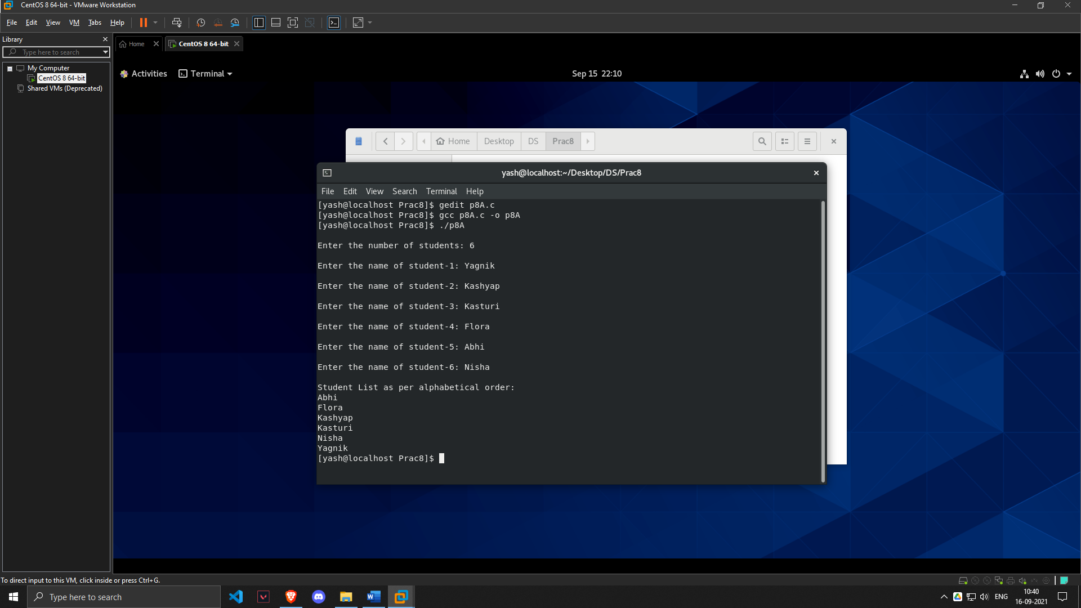

**2. Jigar wants check for those strings which are having same reverse string as original. For instance:**

**Case 1:**

**Enter the String: manali**

**Reverse String: ilanam**

**Result: Not Same as original**

**Case 2:**

**Enter the String: madam**

**Reverse String: madam**

**Result: Same as original**

***SOLUTION***

#include <stdio.h>

#include <string.h>

int main()

{

char yash[30], prajapati[30];

int len=0 ,j=0;

printf("Enter the String : ");

scanf("%s",yash);

len=strlen(yash);

for(int i=len-1 ; i>=0 ; i--)

{

prajapati[j]=yash[i];

j++;

}

printf("\nReverse String: %s",prajapati);

if (strcmp(yash, prajapati) == 0)

{

printf("\nResult: Same as original");

}

else

{

printf("\nResult: Not same as original");

}

return 0;

}

***OUTPUT***

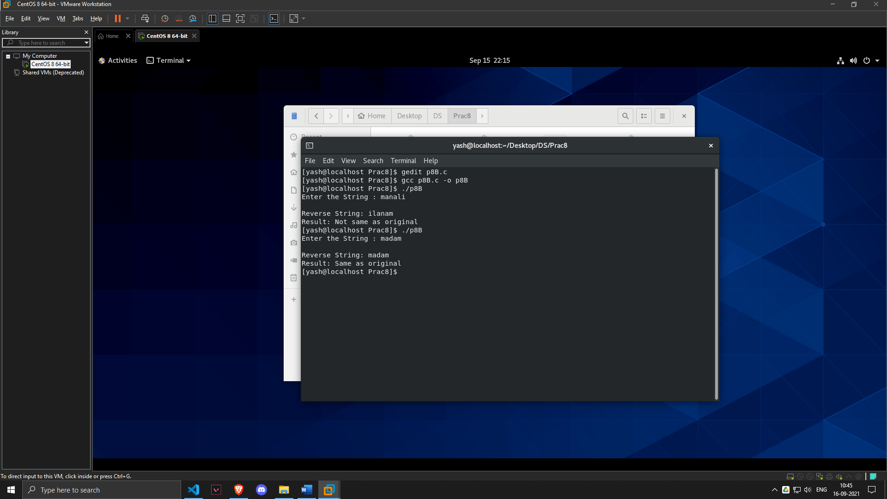

**Homework Task Submission:**

**1. Develop an algorithm for inserting a new string at given position.**

**i.e. Enter Main String: Cls**

**Enter New String: as**

**Enter location where you want to insert the new string: 2**

**Final String: Class**

***SOLUTION***

#include<stdio.h>

#include<string.h>

int main()

{

char Yash1[10],Yash2[10],Yash3[10];

int pos,len1,len2,length,temp2,temp=0,temp1;

int i=0;

printf("\nEnter main string: ");

scanf("%s",Yash1);

printf("\nEnter new string: ");

scanf("%s",Yash2);

printf("\nEnter position from where you want to insert new string: ");

scanf("%d",&pos);

len1=strlen(Yash1);

len2=strlen(Yash2);

while(i<=len1)

{

Yash3[i]=Yash1[i];

i++;

}

length=len1+len2;

temp1=len2+pos;

for (int i = pos; i < length; i++)

{

temp2=Yash3[i];

if (temp<len2)

{

Yash1[i]=Yash2[temp];

temp++;

}

Yash1[temp1]=temp2;

temp1++;

}

printf("%s\n\n",Yash1);

return 0;

}

***OUTPUT***

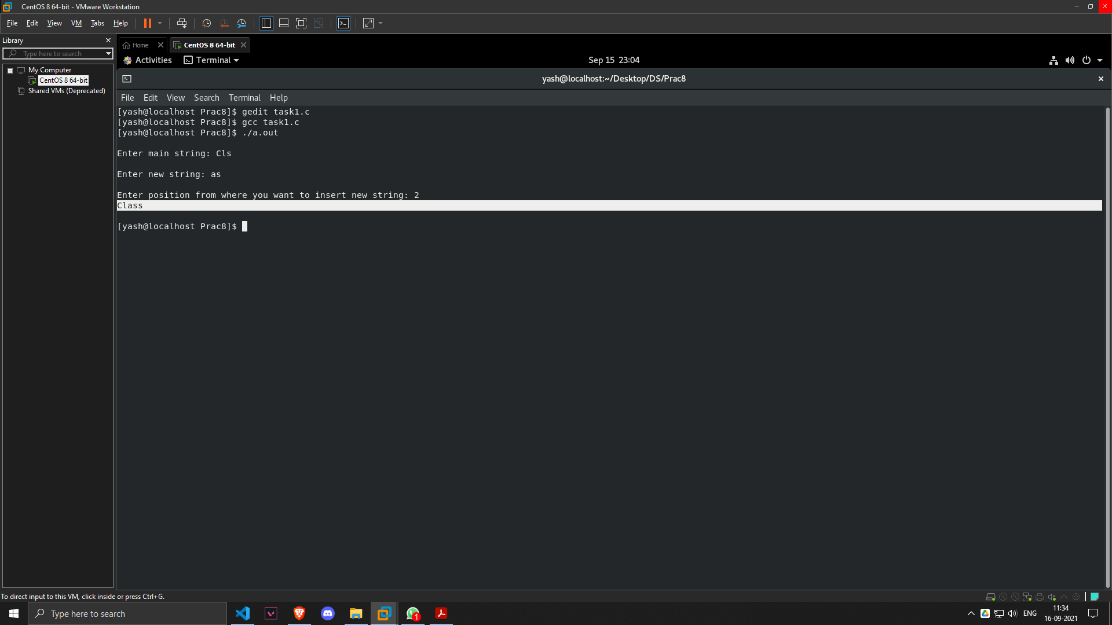

**2. Implement a C code to inserting new string in the main string.**

**i.e. Enter first string: DS**

**Enter Second string: Class**

**Final string: DSClass**

***SOLUTION***

#include <stdio.h>

int main()

{

char first[20], second[20], yash[20];

int i = 0, j = 0;

printf("\nEnter First string: ");

scanf("%s",first);

printf("\nEnter Second string: ");

scanf("%s",second);

while (first[i] != '\0') {

yash[j] = first[i];

i++;

j++;

}

i = 0;

while (second[i] != '\0') {

yash[j] = second[i];

i++;

j++;

}

yash[j] = '\0';

printf("\nFinal string: %s\n", yash);

return 0;

}

***OUTPUT***

